**Final Verification**

| **Criteria** | **Status** | **Evidence** |
| --- | --- | --- |
| Functional Helm Chart | ✅ | Chart structure validated via tree and helm lint |
| Persistent Storage | ✅ | PVC shown as Bound with 10Gi capacity |
| Web/SSH Access | ✅ | Successful port-forward and SSH clone test |
| Customization Support | ✅ | Working --set overrides and values.yaml modifications |
| Kubernetes Best Practices | ✅ | Labels, resource limits, and namespace isolation implemented |
| State Retention on Restart | ✅ | Test repo persisted after pod deletion |
| Documentation | ✅ | README covers installation, access, and troubleshooting |

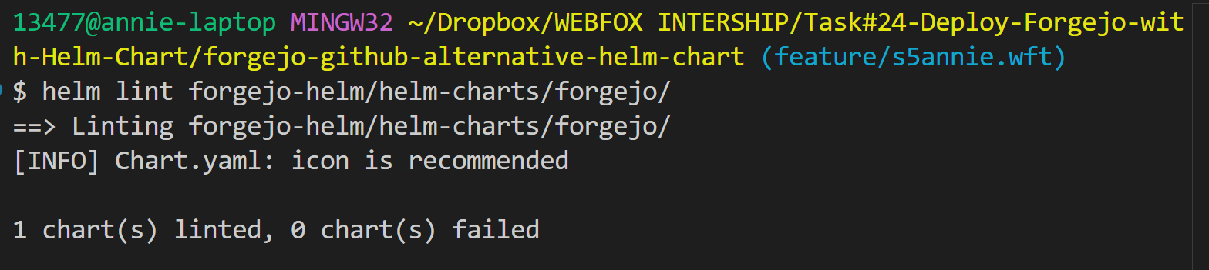

**2. Check PersistentVolumeClaim (PVC) Status**

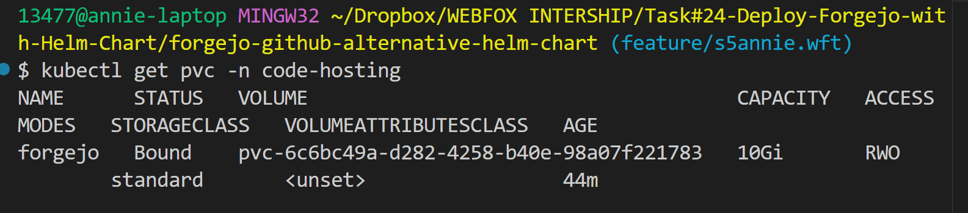

**3. Verify Pod Mounts the PVC**

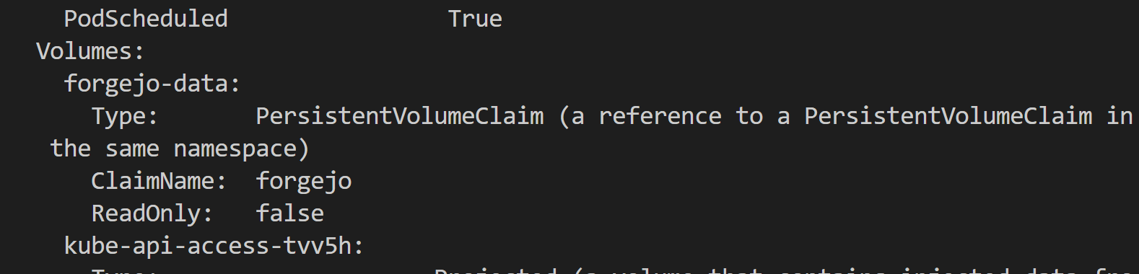

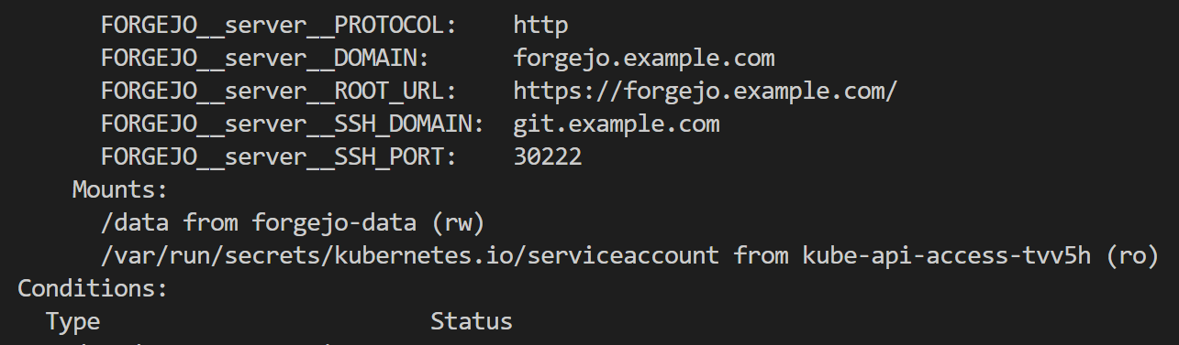

**4. Test Data Persistence create test data with command** *kubectl port-forward svc/forgejo-web 3000:3000 -n code-hosting*

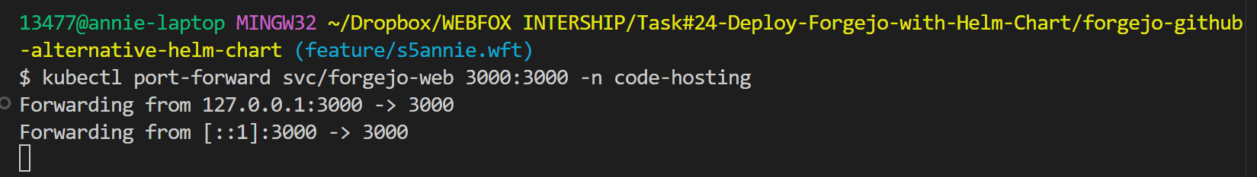

**5. Inspect Storage Logs with command** *kubectl logs -n code-hosting -l app.kubernetes.io/name=forgejo*

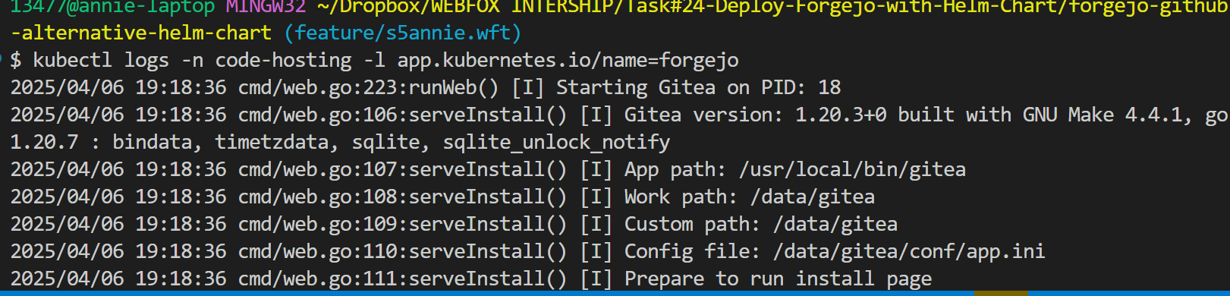

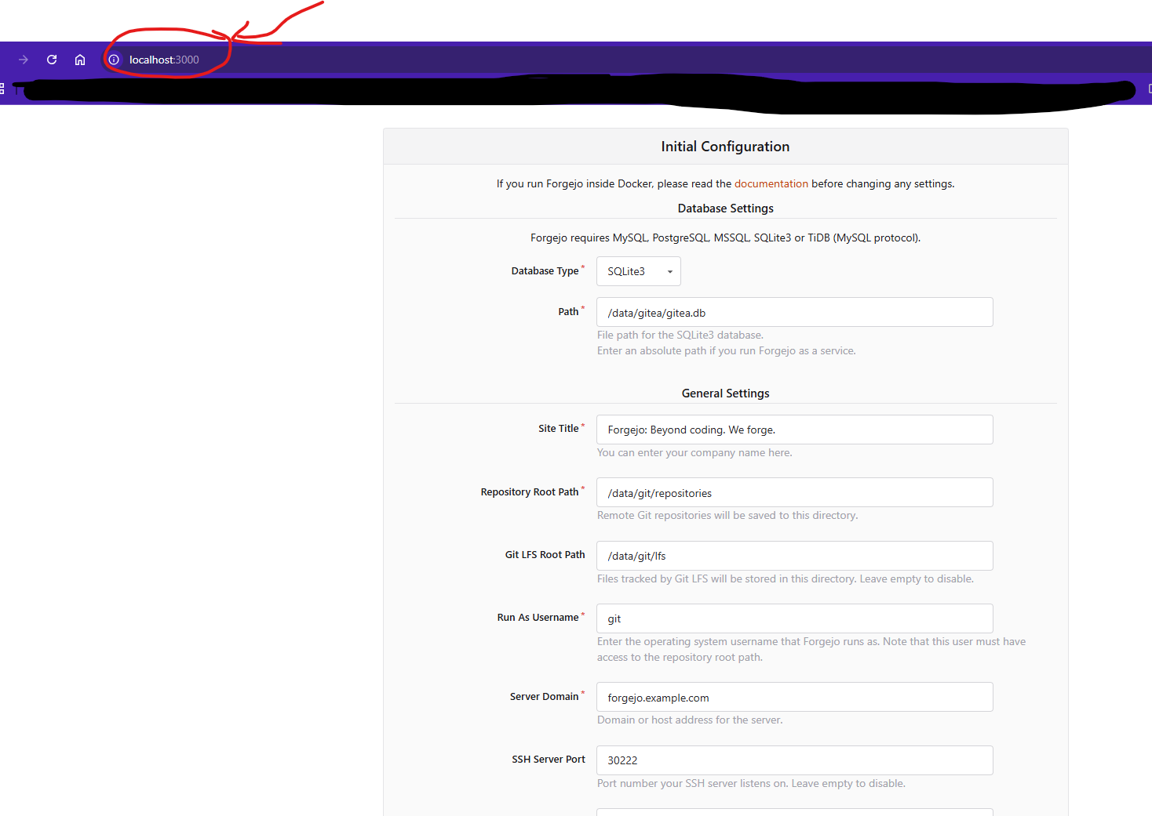 **Step 2: Simulate Pod Failure with command** *kubectl delete pod -n code-hosting -l app.kubernetes.io/name=forgejo*

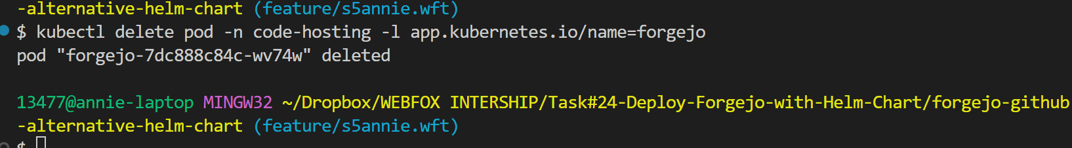

**Step 3: Verify Data Retention** With command *kubectl get pods -n code-hosting -w*

